Районная олимпиада по английскому языку 3-4 класс _________________________

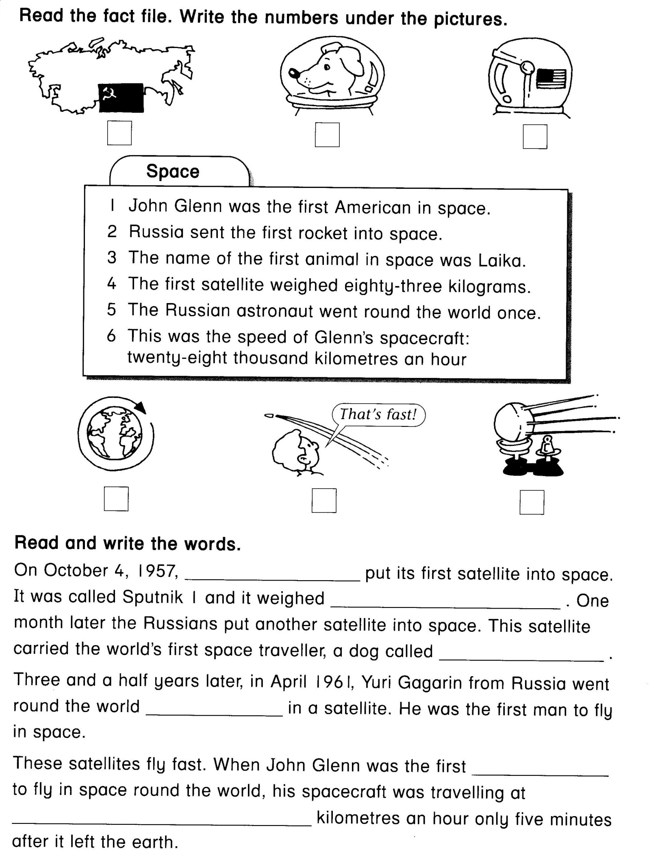
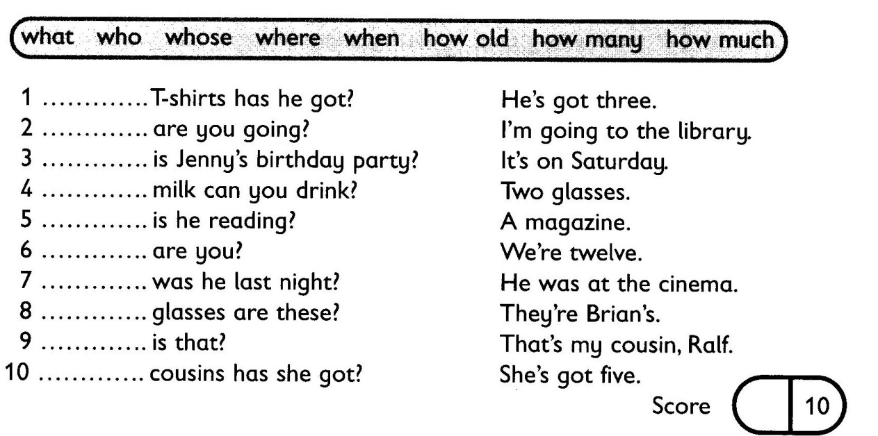
Choose the right variant.
1. I ( am, is, are) at the zoo.

2. We ( is, are, am) from Russia.

3. My sister ( have got, has got ) a doll.

4. My brother and I ( have got, has got ) a nice dog.

5. The dog ( like, likes ) to play with my toys.

6. There ( is, are ) two children in the classroom.

7. There ( is, are) a banana on the table.

8. I`ve got ( a, an, - ) orange.

9. There (is, are ) a kitchen in my flat.

10. ( Ann, Ann`s) toys are in the box.

Join the numbers.
1) 11 a) thirty
2) 24 b) fifteen
3) 40 c) twelve
4) 20 d) twenty-four
5) 93 e) eleven
6) 19 f) ninety-three
7) 57 g) forty
8) 12 h) twenty
9) 30 i) nineteen
10) 15 j) fifty-seven

1 | 2 | 3 | 4 | 5 | 6 | 7 | 8 | 9 | 10
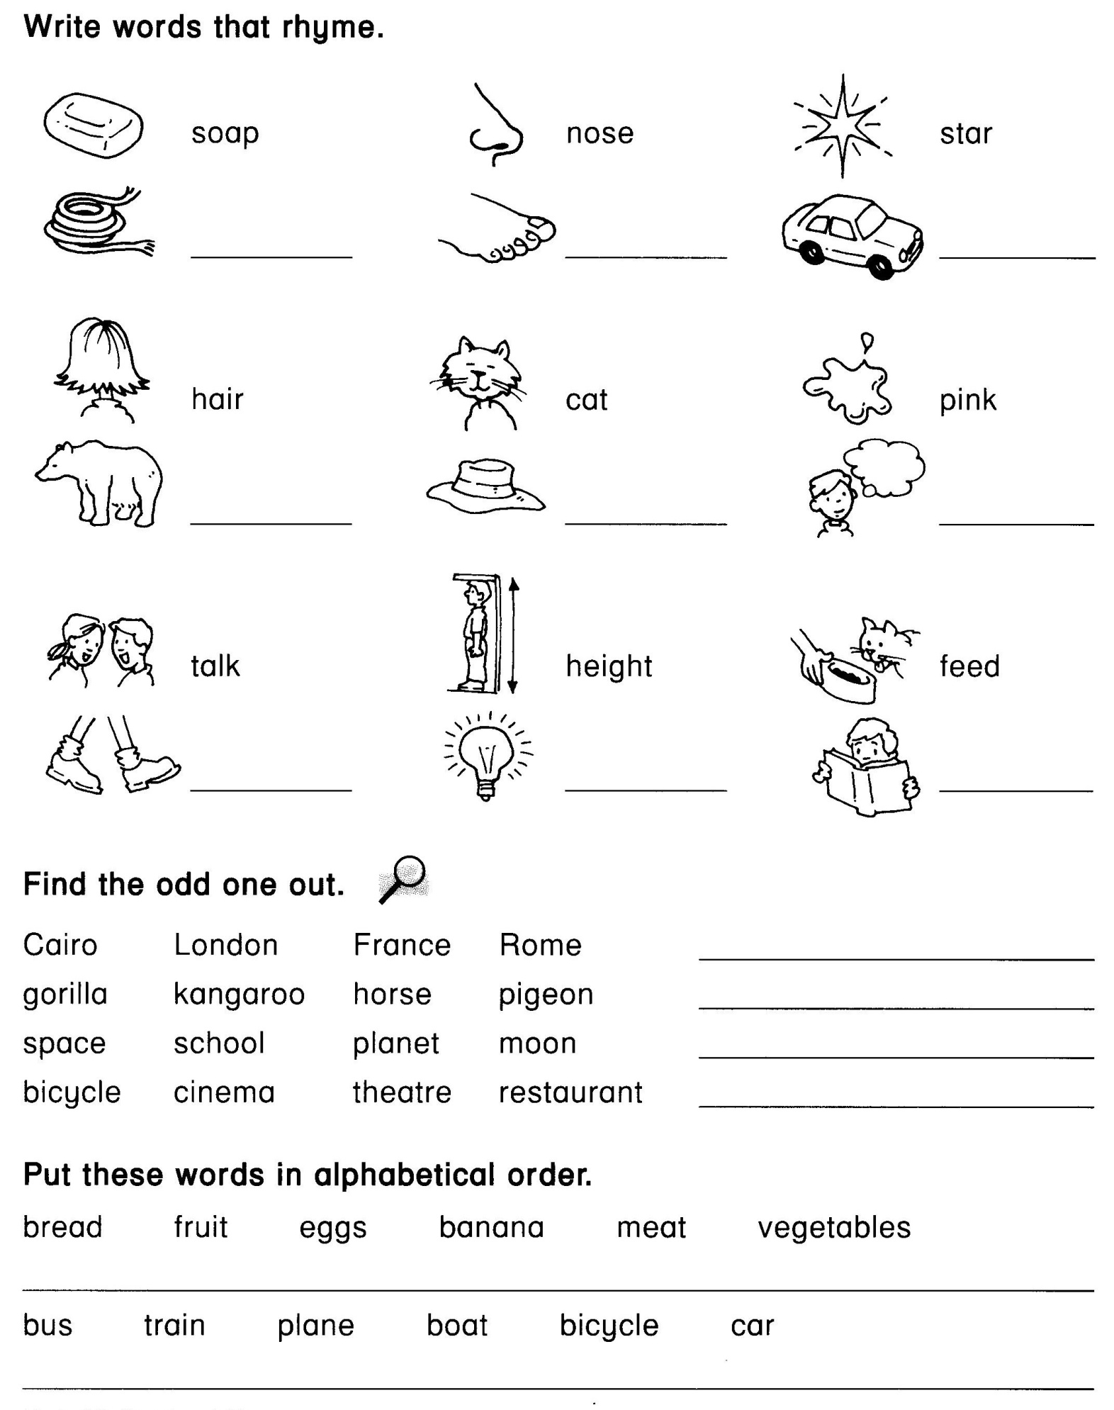
Guess what it is
1. It is very red and sweet, and it is so good to eat.
А) An orange B) An apple C) A carrot
2. What animal has the longest neck?
А) A horse B) A giraffe C) A crocodile
3. It has four legs, a long tail and it can give milk.
А) A sheep B) A pig C) A cow
4. It is white, it is cold, you can ski on it.
А) Sugar B) Chalk C) Snow
5. It has one face and two hands, it goes and yet it stands.
А) A clock B) A baby C) A doll
6. What is it that was tomorrow and will be yesterday?
А) Yesterday B) Today C) Tomorrow
7. What has four legs and a back?
А) A table B) A chair C) A shelf
8. It has no wings but it can fly away.
А) A balloon B) A bird C) A grasshopper
9. I’m an insect. I gather nectar from flowers.
А) A bee B) A bird C) A fly
10. What goes up when the rain comes down?
А) A cloud B) The sky C) An umbrella
Read a letter from a new pen friend. Write an answer to his letter.
Dear Ben,
My name is Wendy. I live in London, England. I am ten years old. My birthday is on the 12th of May. I live with my mum and dad. I haven't got any sisters or brothers. I go to Hillside School. My school is great but it isn’t very big. I’m in class 1a. There are twenty pupils in my class. I like my classmates. They are very friendly. Have you got any friends in your class? My favourite subjects are English and Music. I don’t like Maths because I’m not very good at it. What’s your favourite subject? I like reading books in my free time. I can sing and dance quite well. What about you? I hope to hear from you soon.
Yours, Wendy
Dear ______________ It was great to get your letter.
My name ______________________________ I live in _____________________________
I am _____________________________ I live with _______________________________
__________I _________________________friends in my class. My favourite school subject ________________________________________ In my free time___________________
I can __________________________________________________________________
Yours, ____________________________

