**Районная олимпиада по английскому языку 5-6 класс _________________________**

1. **Listening**

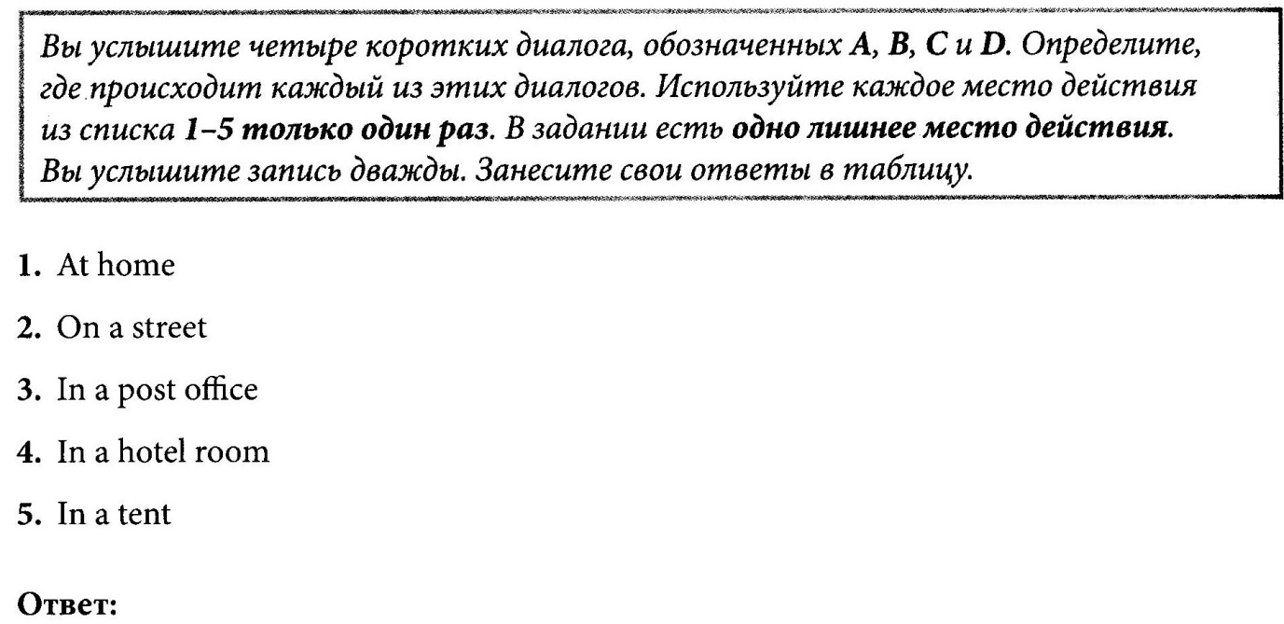

|  |  |  |  |  |
| --- | --- | --- | --- | --- |
| **Диалог** | **A** | **B** | **С** | **D** |
| **Место действия** |  |  |  |  |



1. **Reading**

**Schools in Great Britain**

|  |
| --- |
| **I** *Прочитайте текст. Определите, какие из приведенных утверждений 1-5 соответствуют содержанию текста* ***(True)*** *какие не соответствуют* ***(False)*** *и о чем в тексте несказанно, то есть на основании текста нельзя дать ни положительного, ни отрицательного ответа* ***(Not stated).***  **Read the text and decide if the statements are true, false or not stated.** |

1. In Great Britain boys and girls begin to go to school when they are six.­­­_____
2. English schools work five days a week._______
3. On Saturdays and Sundays pupils have sports competitions at school.______
4. There no primary schools in Great Britain.______
5. Children go to primary schools till they are 12.______

***Score ______***

**Schools in Great Britain**

In Great Britain boys and girls begin to go to school when they are five years old. Some boys and girls go to school till they are fifteen years old, others go up to sixteen or eighteen.

English schools are open five days a week. On Saturdays and Sundays there are no lessons.

There are primary and secondary schools in Great Britain. English children begin to go to a secondary school when they are eleven or older. There are different kinds of secondary schools in Britain. Some secondary schools are only for boys, some are only for girls and some are for boys and girls. Some schools prepare pupils for work, others for the university.

The pupils of all schools have uniforms. The boys wear dark grey, dark green or dark blue uniforms. The girls in some schools wear blouses and skirts, in others they wear dresses.

|  |
| --- |
| **II** Прочитайте текст. В заданиях 6- 10 выберите правильный вариант ответа.  **Choose the right variant.** |

1. **In Great Britain there are**
2. no primary schools.
3. primary and secondary schools.
4. only primary school.
5. **English children begin to go to a secondary school**
6. when they are 11 or 12.
7. when they are 9 or 10.
8. when they are 5 or 6.
9. **In Britain there are secondary schools**
10. only for boys.
11. only for girls.
12. only for boys and girls.
13. **Some schools prepare pupils**
14. for sports and work.
15. for work and university.
16. for university.
17. **All schoolchildren wear**
18. dark grey uniforms.
19. blouses and skirts.
20. uniforms at schools. ***Score ______***

**IV. Преобразуйте слова в конце строк так, чтобы они грамматически соответствовали содержанию текста и впишите их в пропуски.**

|  |  |  |
| --- | --- | --- |
|  | Once upon a time there lived a boy called Jack. He and 1____________ mother 2____________very poor. One day mother said:”We don’t have 3_____________________ to eat. We must sell the cow.” So Jack   4_____________to the market with the cow. On the way he met two old 5________________.They said: “We want to buy your cow but we don’t have money. We have only five magic beans.” | 1 HE  2 BE  3 SOMETHING  4 GO  5 MAN |

***Score ______***

**V. Put the verbs in brackets into the *present simple* or *present continuous*.**

1. Ben……………………………………………………**( always/wear)**a suit to work.
2. We …………………………………………………**(watch)**the parade at the moment.
3. Mum ……………………………………………………**(not/take)**photographs now.
4. It usually ……………………………………..…**(snow)**a lot in the winter in Canada.
5. The sun ………………………………………..**(shine)**brightly**.** – It’s a beautiful day!
6. He …………………………………………………………**(want)** to buy some carrots.
7. …………………………………………………....**(  they / have )** breakfast every day?
8. She …………………………………………………………………**(drink)**coffee now.

***Score _____***

**VI. Underline the right form of the verb.**

**1**. He (is driving/drives/ drive ) a car now.**2**. They (are writing/is writing/writes ) a letter at the moment.**3**. Look! It (is raining/rains/rain).**4**. He (reads/ is reading/are reading) now.**5**. My parents (lives / live/are living) in a detached house.

**6**. The sun (rise/ rises ***/***is rising) in the East.

**7.** (Is/Does/Are) she eating now?

**8.** (Are you usually have / Do you usually have/Does you usually have) lunch  at  work?

**9**.  I (am drinking/drinks/drink) too much coffee.

**10**. She ( is sitting/sits/sit ) on a sofa now.                                                                       ***Score_____***

**VII. Put the verbs in brackets into the *past simple* or *present perfect*.**

**1.** They …………………………….. **(leave)** for Italy last night.

**2**.We …………………………………. **(already/book)** the tickets.

**3**.………………………………………**(you/ever/be)** abroad?

**4.**He’s tired. He ……………………….. **(just/ finish)** work.

**5**.Maria …………………………………. **(travel)** abroad last year.

**6**.Gary ……………………………………… **(not/ arrive)** yet.

**7**.We …………………………………….. **(move)** to Rome last year.

**8**.Sam …………………………………. **(go)** bungee jumping last summer.

**9**.Lisa …………………………………….. **(cycle)** across country many times.

**10.**Paul …………………………………..**(ride)**a camel last year.                                        ***Score   _____***

**VIII. Choose the correct form, circle it.**

1.I need a bread knife and two butter _______.

      a) knifes       b) knives       c) knivs

2.The baby has  one tooth. When he is three he will have twenty _______.

      a) teeth       b) tooths       c) teeths  
3. There is a policeman outside the bank and there are four ______inside the bank.

      a) policemans       b) policemens       c) policemen  
4. I have a sister.  _______ sister is an actress.

      a) my       b) his       c) our

5.Look at these elephants. I like _______.

      a) him       b) it       c) them

6.Football is _______ sport in the world.

       a) more popular       b)the most popular       c) popularest

7.Molly is _______ at science than Jennifer.

       a) gooder       b) better       c) the best

8.He starts work _______ 9 o’clock.

       a) in       b) of       c) at

9.The flat is _______ the third floor.

       a) on       b) in       c) at

10.She _______ a student two years ago.

       a) were       b) is       c) was

11.Emma is of …..  height.

        a) medium    b) tall     c) short.      ***Score _____***

**IX.**

